https://docs.gimp.org/2.10/en/:
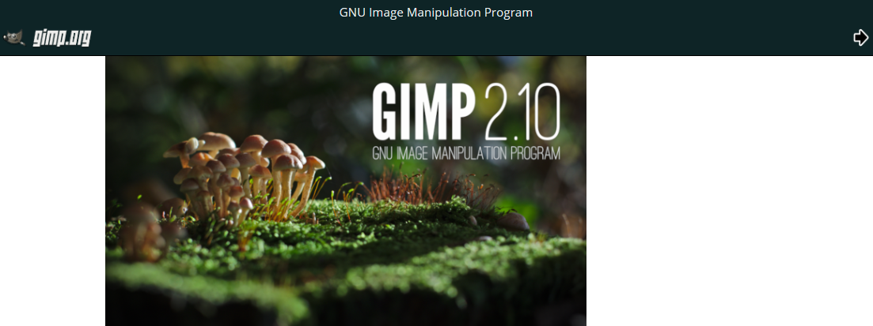

GNU Image Manipulation Program

User Manual
Copyright © 2002, 2003, 2004, 2005, 2006, 2007, 2008, 2009, 2010, 2011, 2012, 2013, 2014, 2015, 2016, 2017, 2018 The GIMP Documentation Team
Legal Notice
Permission is granted to copy, distribute and/or modify this document under the terms of the GNU Free Documentation License, Version 1.2 or any later version published by the Free Software Foundation; with no Invariant Sections, no Front-Cover Texts, and no Back-Cover Texts. A copy of the license is included in the section enphrased GNU Free Documentation License.

Contents
GNU Image Manipulation Program 1
User Manual 1
Preface 2
1. GIMP User Manual Authors and Contributors 2

Preface

1. GIMP User Manual Authors and Contributors
Content Writers
Alex Muñoz (Spanish) , Alexandre Franke (French) , Alexandre Prokoudine (Russian) , Angelo Córdoba Inunza (Spanish) , Christian Kirbach (German) , Daniel Francis (Spanish) , Daniel Mustieles (Spanish) , Daniel Winzen (German) , Delin Chang (Chinese) , Dimitris Spingos (Greek) , Djavan Fagundes (Brasilian) , Enrico Nicoletto (Brasilian) , Felipe Ribeiro (Brasilian) , Guiu Rocafort (Spanish) , Jiro Matsuzawa (Japanese) , Joe Hansen (Danish) , João S. O. Bueno (Brasilian) , Julien Hardelin (French, English) , Kenneth Nielsen (Danish) , Kolbjørn Stuestøl (Norwegian) , Marco Ciampa (Italian) , María Majadas (Spanish) , Milagros Infante Montero (Spanish) , Milo Casagrande (Italian) , Piotr Drąg (Polish) , Rafael Ferreira (Brasilian) , Róman Joost (German, English) , Seong-ho Cho (Korean) , SimaMoto,RyōTa (島本良太) (Japanese) , Sven Claussner (German, English) , Timo Jyrinki (Finnish) , Ulf-D. Ehlert (German) , Vitaly Lomov (Russian) , Willer Gomes Junior (Brasilian) , Yuri Myasoedov (Russian) , Equip de Softcatalà (ca)
Proof Reading
Stéphane Poumaer (French) , Axel Wernicke (German, English) , Alessandro Falappa (Italian) , Manuel Quiñones (Spanish) , Ignacio AntI (Spanish) , Choi Ji-Hui(최지희) (Korean) , Nickolay V. Shmyrev (Russian) , Albin Bernharsson (Swedish) , Daniel Nylander (Swedish) , Patrycja Stawiarska (Polish) , Andrew Pitonyak (English) , Jakub Friedl (Czech, English) , Hans De Jonge (Dutch) , Raymon Van Wanrooij (Dutch) , Semka Kuloviæ-Debals (Croatian) , Sally C. Barry (English) , Daniel Egger (English) , Sven Neumann (English, German) , Domingo Stephan (German) , Thomas Lotze (German) , Thomas Güttler (German) , Zhong Yaotang (Chinese) , Calum Mackay (English) , Thomas S Lendo (German) , Mel Boyce (syngin) (English) , Oliver Ellis (Red Haze) (English) , Markus Reinhardt (German) , Alexander Weiher (German) , Michael Hölzen (German) , Raymond Ostertag (French) , Cédric Gémy (French) , Sébastien Barre (French) , Niklas Mattison (Swedish) , Daryl Lee (English) , William Skaggs (English) , Cai Qian (蔡芊) (Chinese) , Yang Hong (杨红) (Chinese) , Xceals (Chinese) , Eric Lamarque (Chinese) , Robert van Drunen (Dutch) , Marco Marega (Italian) , Mike Vargas (Italian) , Andrea Zito (Italian) , Karine Delvare (French) , David 'Ilicz' Klementa (Czech) , Jan Smith (English) , Adolf Gerold (German) , Roxana Chernogolova (Russian) , Grigory Bakunov (Russian) , Oleg Fritz (Russian) , Mick Curtis (English) , Vitaly Lomov (Russian) , Pierre PERRIER (French) , Oliver Heesakke (Dutch) , Susanne Schmidt (English, German) , Ben (German) , Daniel Hornung (English) , Sven Claussner (English, German)
Graphics, Stylesheets
Jakub Steiner , Øyvind Kolås
Build System, Technical Contributions
Kenneth Nielsen , Róman Joost , Axel Wernicke , Nickolay V. Shmyrev , Daniel Egger , Sven Neumann , Michael Natterer (mitch) , Henrik Brix Andersen (brix) , Thomas Schraitle , Chris Hübsch , Anne Schneider , Peter Volkov , Daniel Richard

